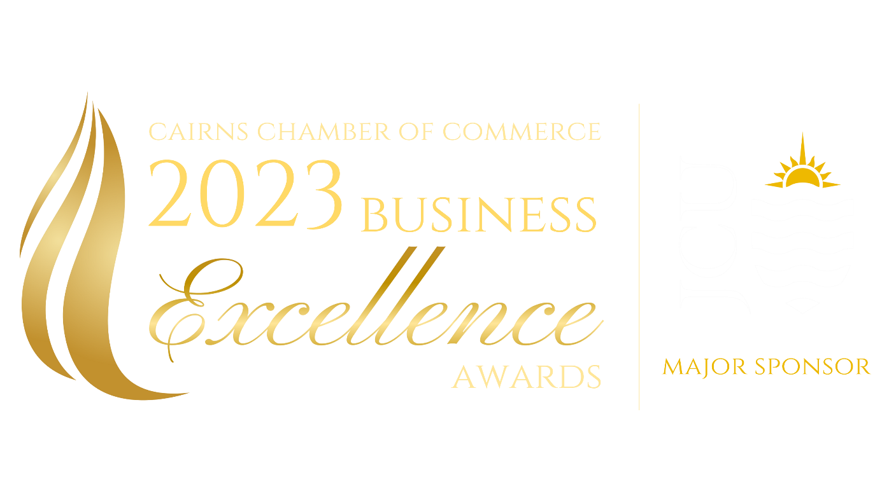
Written Submission Questions
2023 Cairns Chamber of Commerce Business Excellence Awards Written Submission Questions
Please use this document to draft your responses to the written submission questions for the category that you are entering. Once you are satisfied with your answers, you can copy-and-paste your responses into the Award Force online application form.
To be considered for the awards, your application must be submitted online via https://bexawards.awardsplatform.com/

Table of Contents – Award Selection Criteria
Business Technology Excellence Award 2
Community Contribution Excellence Award 3
Customer Service Excellence Award - Professional Services 4
Customer Service Excellence Award – Trade, Retail & Services 5
Indigenous Business Excellence Award 6
Innovation Excellence Award 7
Marketing and Communications Excellence Award 8
People Management Excellence Award 9
Sustainability and Environmental Excellence Award 10
Emerging Leader Excellence Award 11

Business Technology Excellence Award
This award recognises a business that has implemented new or advanced technologies into their business and/or within their client’s business to drive performance, growth and/or profitability.

Describe Your Business (20%)
Your response should include reference to:
- What is the nature of your business - what do you do?
- Provide a snapshot of your business’s history and a brief insight into your business today.
- What are some of the key challenges you have faced and how have you managed to overcome them?
- What drives success in your business?
- What are your main business goals and the strategies you have implemented to achieve them?

600 words maximum

Business Technology Excellence (60%)
Your response should include reference to:
- Explain the business case for driving the introduction of new or advanced technologies within your business and/or within a client’s business.
- Describe the technologies that you have implemented, including any mistakes or challenges that you faced along the way.
- Outline how this technology has driven performance, growth and/or profitability and how you have measured this success. Include quantifiable metrics where possible.

2000 words maximum

Community Contribution and Corporate Social Responsibility (20%)
Your response should include reference to:
- What is the social impact of your business on the Cairns community?
You may wish to consider how your business contributes to improvements in people's lives in any of the following ways:
  - Wellbeing and lifestyle
  - Culture and diversity
  - Inclusion and accessibility
  - Mentorship and education
- Outline and provide examples of your commitment to Corporate Social Responsibility. You may wish to consider how your business incorporates environmental, ethical and/or philanthropic initiatives into its operations?

500 words maximum

Community Contribution Excellence Award
This award recognises a business that has achieved outstanding results in the implementation of Corporate Social Responsibility (CSR) initiatives. CSR needs to be incorporated into their business strategy, extending beyond the financial bottom line, and integrating social, ethical, environmental and/or philanthropic values into core decision-making processes and company culture.

Describe Your Business (20%)
Your response should include reference to:
- What is the nature of your business - what do you do?
- Provide a snapshot of your business’s history and a brief insight into your business today.
- What are some of the key challenges you have faced and how have you managed to overcome them?
- What drives success in your business?
- What are your main business goals and the strategies you have implemented to achieve them?

600 words maximum

Corporate Social Responsibility Best Practice (80%)
Your response should include reference to:
- Demonstrate how CSR is reflected in your vison, mission and/or values.
- Outline at least two specific examples (social, ethical, environmental and/or philanthropic) of how your business’s CSR initiatives have positively impacted the Cairns community.
- Describe your future plans for the continuation of your business’s commitment to CSR.
- Demonstrate how your business has achieved success through your commitment to CSR.

2500 words maximum

Customer Service Excellence Award - Professional Services
This award recognises a professional services business that has maximised performance, achieved growth and/or increased profitability through focusing on excellent customer service.

Describe Your Business (20%)
Your response should include reference to:
- What is the nature of your business - what do you do?
- Provide a snapshot of your business’s history and a brief insight into your business today.
- What are some of the key challenges you have faced and how have you managed to overcome them?
- What drives success in your business?
- What are your main business goals and the strategies you have implemented to achieve them?

600 words maximum

Customer Service Excellence (60%)
Your response should include reference to:
- Describe and provide examples of any outstanding customer service initiatives that your business has implemented.
- Provide evidence of how these customer service initiatives have created success for your business. Include quantifiable metrics where possible.

You may wish to consider:
- How you measure customer satisfaction and identify areas for improvement.
- How you train and ensure your staff maintain your customer service standards.
- What processes you have in place to respond to customer complaints.

2000 words maximum

Community Contribution and Corporate Social Responsibility (20%)
Your response should include reference to:
- What is the social impact of your business on the Cairns community?
You may wish to consider how your business contributes to improvements in people's lives in any of the following ways:
  - Wellbeing and lifestyle
  - Culture and diversity
  - Inclusion and accessibility
  - Mentorship and education
- Outline and provide examples of your commitment to Corporate Social Responsibility. You may wish to consider how your business incorporates environmental, ethical and/or philanthropic initiatives into its operations?

500 words maximum

Customer Service Excellence Award – Trade, Retail & Services
This award recognises a trade, retail or services business that has maximised performance, achieved growth and/or increased profitability through focusing on excellent customer service.

Describe Your Business (20%)
Your response should include reference to:
- What is the nature of your business - what do you do?
- Provide a snapshot of your business’s history and a brief insight into your business today.
- What are some of the key challenges you have faced and how have you managed to overcome them?
- What drives success in your business?
- What are your main business goals and the strategies you have implemented to achieve them?

600 words maximum

Customer Service Excellence (60%)
Your response should include reference to:
- Describe and provide examples of any outstanding customer service initiatives that your business has implemented.
- Provide evidence of how these customer service initiatives have created success for your business. Include quantifiable metrics where possible.

You may wish to consider:
- How you measure customer satisfaction and identify areas for improvement.
- How you train and ensure your staff maintain your customer service standards.
- What processes you have in place to respond to customer complaints.

2000 words maximum

Community Contribution and Corporate Social Responsibility (20%)
Your response should include reference to:
- What is the social impact of your business on the Cairns community?
You may wish to consider how your business contributes to improvements in people's lives in any of the following ways:
  - Wellbeing and lifestyle
  - Culture and diversity
  - Inclusion and accessibility
  - Mentorship and education
- Outline and provide examples of your commitment to Corporate Social Responsibility. You may wish to consider how your business incorporates environmental, ethical and/or philanthropic initiatives into its operations?

500 words maximum

Indigenous Business Excellence Award
This award recognises a majority Indigenous owned and/or operated business for exceptional business practices and achievements.

Business Overview (20%)
Your response should include reference to:
- What is the nature of your business - what do you do?
- Provide a snapshot of your business’s history and a brief insight into your business today.
- What are your main business goals and the strategies you have implemented to achieve them?
- What is your unique selling proposition and how do you communicate this to your target markets?

600 words maximum

Business Best Practice and Achievements (80%)
Your response should include reference to:
- Outline at two exceptional achievements that your business has accomplished. Explain how success was achieved and what challenges had to be overcome.
- Demonstrate how your business displays strong leadership and people management.
- Demonstrate your commitment to the acknowledgement, promotion and/or conservation of Indigenous culture. Identify how best practice in cultural management has driven performance excellence in your business.
- Demonstrate your commitment to the personal, professional and/or career development of Indigenous people.
You may wish to consider how your business contributes to improvements in people's lives in any of the following ways:
  - Wellbeing and lifestyle
  - Culture and diversity
  - Inclusion and accessibility
  - Mentorship and education
- Outline and provide examples of your commitment to Corporate Social Responsibility. You may wish to consider how your business incorporates environmental, ethical and/or philanthropic initiatives into its operations?

2500 words maximum

Innovation Excellence Award
This award recognises a business that has successfully developed and/or implemented an innovative new product, service, process or business model, that has commercial, social or organisational value, and has subsequently driven performance, growth and/or profitability.

Describe Your Business (20%)
Your response should include reference to:
- What is the nature of your business - what do you do?
- Provide a snapshot of your business’s history and a brief insight into your business today.
- What are some of the key challenges you have faced and how have you managed to overcome them?
- What drives success in your business?
- What are your main business goals and the strategies you have implemented to achieve them?

600 words maximum

Innovation Excellence (60%)
Your response should include reference to:
- Describe the business case for the innovation that has driven positive change in your business.
- Describe the innovation that have been developed and implemented, the mistakes and challenges during the implementation and the outcomes that have been achieved.
- Demonstrate how your business has maximised performance, achieved growth and/or increased profitability through the implementation of this innovation.

2000 words maximum

Community Contribution and Corporate Social Responsibility (20%)
Your response should include reference to:
- What is the social impact of your business on the Cairns community?
You may wish to consider how your business contributes to improvements in people's lives in any of the following ways:
  - Wellbeing and lifestyle
  - Culture and diversity
  - Inclusion and accessibility
  - Mentorship and education
- Outline and provide examples of your commitment to Corporate Social Responsibility. You may wish to consider how your business incorporates environmental, ethical and/or philanthropic initiatives into its operations?

500 words maximum

Marketing and Communications Excellence Award
This award recognises a business that has a well-targeted and engaging marketing approach that has demonstrably contributed to their success and/or their client’s success.

Describe Your Business (20%)
Your response should include reference to:
- What is the nature of your business - what do you do?
- Provide a snapshot of your business’s history and a brief insight into your business today.
- What are some of the key challenges you have faced and how have you managed to overcome them?
- What drives success in your business?
- What are your main business goals and the strategies you have implemented to achieve them?

600 words maximum

Marketing and Communications Excellence (60%)
Your response should include reference to:
- Provide examples of innovative marketing techniques that you have developed.
- Provide at least two specific examples of creative marketing campaigns that you have developed, including the success of the campaigns and how you measured their success.
- Demonstrate how your business, and/or your client’s business has achieved business growth and/or profitability through exceptional marketing and communications.

2000 words maximum

Community Contribution and Corporate Social Responsibility (20%)
Your response should include reference to:
- What is the social impact of your business on the Cairns community?
You may wish to consider how your business contributes to improvements in people's lives in any of the following ways:
  - Wellbeing and lifestyle
  - Culture and diversity
  - Inclusion and accessibility
  - Mentorship and education
- Outline and provide examples of your commitment to Corporate Social Responsibility. You may wish to consider how your business incorporates environmental, ethical and/or philanthropic initiatives into its operations?

500 words maximum

People Management Excellence Award
This award recognises a business that has achieved outstanding success through effective people management.

Describe Your Business (20%)
Your response should include reference to:
- What is the nature of your business - what do you do?
- Provide a snapshot of your business’s history and a brief insight into your business today.
- What are some of the key challenges you have faced and how have you managed to overcome them?
- What drives success in your business?
- What are your main business goals and the strategies you have implemented to achieve them?

600 words maximum

People Management Best Practice (60%)
Your response should include reference to:
- Describe the workplace culture within your business and explain how this has developed/transpired.
- Describe any innovative people management initiatives that have been implemented to drive best practice.
- Provide evidence of how these initiatives have directly contributed to your business’s success.

You may wish to consider:
- How you measure and monitor employee satisfaction.
- How you challenge and motivate your team.
- How you celebrate wins in your business.
- What training and professional development is in place for staff and/or volunteers.
- How you develop and foster management and leadership qualities.
- How you approach and manage change within your business.

2000 words maximum

Community Contribution and Corporate Social Responsibility (20%)
Your response should include reference to:
- What is the social impact of your business on the Cairns community?
You may wish to consider how your business contributes to improvements in people's lives in any of the following ways:
  - Wellbeing and lifestyle
  - Culture and diversity
  - Inclusion and accessibility
  - Mentorship and education
- Outline and provide examples of your commitment to Corporate Social Responsibility. You may wish to consider how your business incorporates environmental, ethical and/or philanthropic initiatives into its operations?

500 words maximum

Sustainability and Environmental Excellence Award
This award recognises a business who is actively working to reduce the impact of their operations on the environment and/or provides products or services that have a positive environmental impact.

Describe Your Business (20%)
Your response should include reference to:
- What is the nature of your business - what do you do?
- Provide a snapshot of your business’s history and a brief insight into your business today.
- What are some of the key challenges you have faced and how have you managed to overcome them?
- What drives success in your business?
- What are your main business goals and the strategies you have implemented to achieve them?

600 words maximum

Sustainability and Environmental Best Practice (70%)
Your response should include reference to:
- Identify the products, services, processes and/or policies that your business has implemented to reduce its environmental impacts. You may wish to consider:
  - Energy and water efficiency
  - Reduce, reuse, recycle, repurpose initiatives
  - Waste reduction
  - Transport, travel, plant and equipment
  - Environmental footprint
  - Carbon emissions
- Demonstrate the success of these initiatives and the method of measuring your success. Include quantifiable metrics where possible.
- Explain how your business uses these metrics to continually monitor, improve and promote their environmentally sustainable behaviour.
- Outline how your business involves your stakeholders in your sustainability initiatives.
- Detail future plans for continuation of your business’s commitment to environmentally sustainable practises.
- Highlight how sustainability is embedded into your mission, vision and/or values and influences decision making.

2200 words maximum

Community Contribution (10%)
Your response should include reference to:
- What is the social impact of your business on the Cairns community?
You may wish to consider how your business contributes to improvements in people's lives in any of the following ways:
  - Wellbeing and lifestyle
  - Culture and diversity
  - Inclusion and accessibility
  - Mentorship and education
  - Philanthropy

300 words maximum

Emerging Leader Excellence Award
This award acknowledges an individual, aged 18 – 35, who has demonstrated strong professional development and has made a contribution to the Cairns business community as an emerging leader.

The winner will be awarded for their commitment to professional excellence, community service, initiative and leadership.

Emerging Leader Video Presentation (20%)
Required components of the presentation:
- Briefly introduce yourself.
- What are the most important values you demonstrate as a leader?
- Why do you think it is important to give back to your local community, particularly as a young leader?
- As an ambitious emerging leader, what are your thoughts on how the Far North can attract and retain other ambitious young people?
- As someone who has leadership ambition, what do you think is lacking in the current leadership we have in business, advocacy bodies and politics?

5 minutes maximum

Your Professional Development (40%)
Your response should include reference to:
- Demonstrate your commitment to your professional and career development.
- Demonstrate how you have successfully applied this to your career to date.

1000 words maximum

Originality (20%)
Your response should include reference to:
- Demonstrate your originality, what makes you stand out from the crowd?
- What has been the secret to your success?

400 words maximum

Focus on Community (20%)
Your response should include reference to:
- Demonstrate how your leadership has fostered community connection or improvement.
- Describe how you and/or your business has supported and/or benefited the community, particularly in the last 12 months.

600 words maximum

